Mini-Project 1: Downloading Ableton Live and Exporting Your Music (10 Points Total)

Aligns with the following learning objectives:
C1: Bring a musical idea to life using music production software
C2: Understand and utilize Ableton Stock sounds and plugins, and third party VSTs and plugins

Assignment Overview

Purpose
The purpose of Mini-Project 1 is to guide you in setting up Ableton Live, which is the music production software we will be using in this class. We will go over the very basics of creating blank projects, adding midi and audio tracks, exploring sounds in Ableton Live, and ensuring you know how to export your projects. This will allow you to complete all future Mini-Projects in the course!
For Mini-Project 1, you do not need to produce anything musically adept or polished. The goal is simply to verify that your software is working and can output sound.

Due Date
- Mini-project 1 is due on Sunday, April 26 at 11:59PM.
- To submit Mini-project 1, you will need to upload both the Ableton Live project file (.als file) and the exported .WAV file of your work in the Assignment Submission page on Canvas. See the Export and Submit section for more instructions.

Downloading and Installing Ableton Live
For this course, you will need to purchase Ableton Live 12 Intro edition. Ableton Live offers an Education Discount.
Ableton Live also has a 30-day free trial to help you get started, which includes all instruments, effects, and features. To download the free trial, please follow the steps below.

Ableton Live 12 Trial
- Download the Ableton Live 12 Trial.

- Click the Download button. If you are on a Mac, use the dropdown arrow to select the MacOS download.

- Unzip the Ableton Live Installer once it finishes downloading.

- Windows: Extract the downloaded ZIP file, then double-click Ableton Live 12 Trial Installer.exe and follow the setup wizard.
- Mac: Open the downloaded DMG file, then drag Live Trial into your Applications folder.

- Open Ableton Live after installation is complete.

- When Live Trial opens, click “Start your free trial”.

- Your web browser will automatically open. On the web page, you’ll be prompted to log into your Ableton User account, or create a new account if you don’t have one yet.

- After account creation, you can authorize your trial license and your 30-day trial will begin.

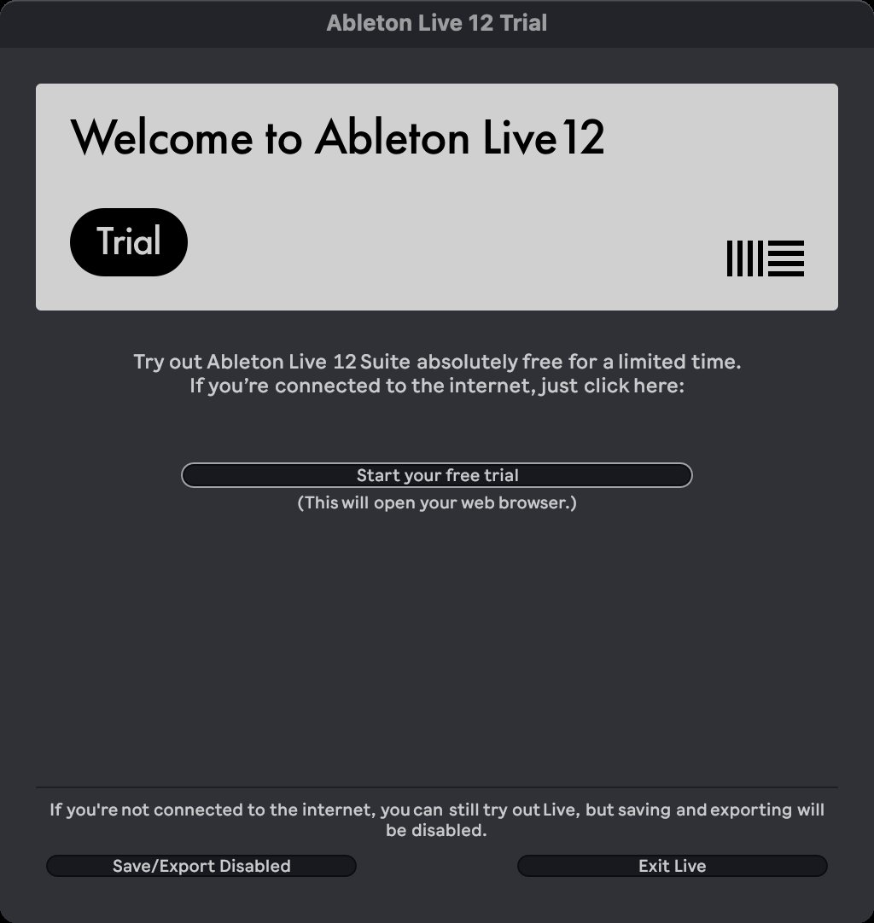
Figure 1: Ableton Live 12 Trial splash screen with the Start your free trial button in the middle.

Creating a New Live Set
Now that you’ve downloaded and installed Ableton Live, we can start by creating a blank project! In Ableton, a project is called a Live Set. Everything you create lives inside of a Live Set.

Blank Projects and Arrangement View
- When Ableton opens, it may load a demo project that comes with your download. To start with a blank project file, go to File > New Live Set.

- After starting a New Live Set, you will immediately switch to Ableton Live’s Arrangement View. This is the configuration that we will be working in for the entirety of the class.

- In the top right-hand corner of Ableton, click on the button with the Thick Horizontal Lines to switch to Arrangement View.

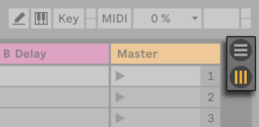
Figure 2: The button with three horizontal lines is the Arrangement View button.

- Now that we have switched to Arrangement View, we are now ready to add Audio and Midi Tracks!

Adding Sounds and Midi Tracks (6/10 Points)
For this part of the assignment, we will be selecting a sound from Ableton’s library to add to our blank project. This part is where you can start getting creative!

Ableton’s Drift Sounds and Midi Clips
- The left area of Ableton is called the Browser. This is where your collection of sounds, recordings, plugins, files, and samples are all organized. For this project, select the Instruments tab under Categories.

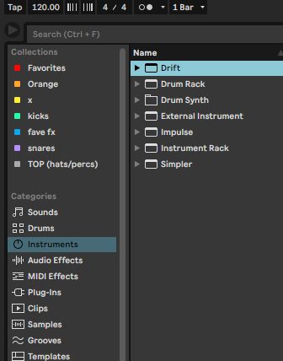
Figure 3: Select Instruments > Drift to find Ableton's default sounds!

- To the right of the Instruments tab, you will see a list of Instruments. Select the Drift instrument dropdown menu, and then click on a sound to preview how it sounds!

- Once you find a sound that interests you, double-click on the sound to add it to your Live Set as a Midi Track. Congratulations! You’ve just added your first midi track to your project.

- Lastly, click and drag your mouse across the grid in the same row as your Midi Track. This should highlight a portion of the grid.

- Right-click on your highlighted portion of the grid and select Insert Empty MIDI Clip(s).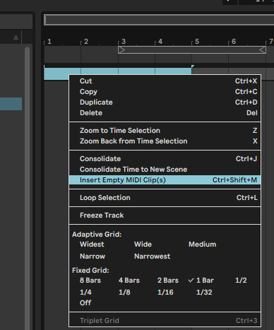
Figure 4: Right-click your highlighted region and select Insert Empty MIDI Clip(s)

- You should see the Piano Roll appear at the bottom of Ableton. You can add notes tthe Piano Roll and press your spacebar to hear what you’ve created!

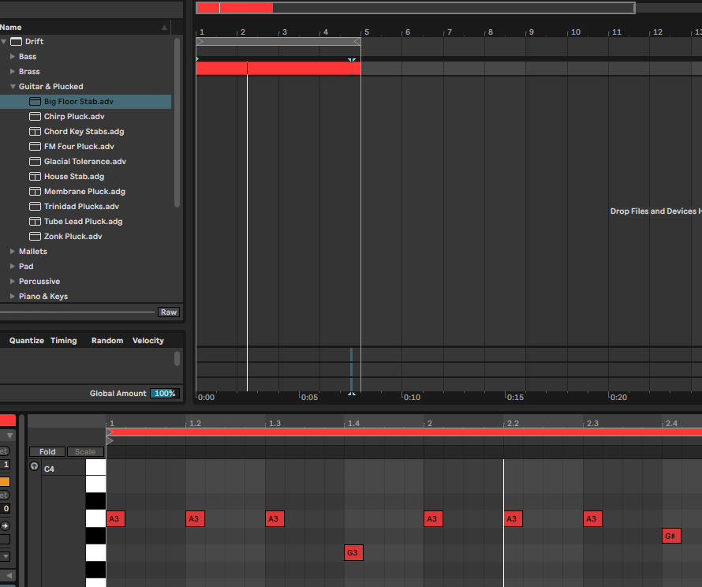
Figure 5: The bottom area is the Piano Roll. Double-click cells here to input notes.

Note: If you hear nothing, check that your computer's volume is up and that Ableton's master volume (the main knob in the upper-right area of the toolbar) is turned up. You can also go to Options > Preferences > Audio to confirm your output device is selected correctly. If you don’t hear anything, try selecting a different Audio Output Device.

Adding Audio Tracks and Looping (4/10 Points)
Audio Tracks work similarly to Midi Tracks. To add an Audio Track, right click a blank area under your midi track and select Insert Audio Track. We won’t be recording anything in Audio Tracks for now.

Looping a Midi Clip
- After inserting some notes into the piano roll, you can set your midi clip to loop. To do this, selecting the Region Locator above your Midi Track. You can hold it with your mouse and drag it to the same region as your Midi Clip.

- Right-Click on the Region Locator and select Loop.

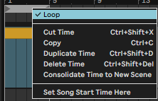
Figure 6: Loop your project with the Region Locator.

- Now press the spacebar to listen to your project. It will loop constantly until you press the spacebar or hit the stop button.

Note: When you export your project in the next section, it will not loop. It will only play the midi clip you created. If you want your exported project to loop, you can right-click on your Midi Clip and copy and paste it one after another!

Export and Submit
Before submitting, confirm that your Live Set contains the following:
- At least one audio track. It can be empty or include recorded content.
- At least one MIDI track with an instrument loaded and at least one note in the piano roll.
- Looping is enabled on your Midi Clip.

How to Submit
- Save your Live Set: File > Save Live Set.
- Select File > Export Audio/Video. This will export your project as a .WAV file.
- Click Export on the window that appears.
- In Canvas, upload your Live Set (.als file) and the .WAV file (the exported file).

Congratulations, you have now completed Mini-Project 1! Feel free to begin exploring Ableton Live, including everything we went over in this assignment, including adding midi and audio tracks to your project, exploring sounds in Drift, using the piano roll, and looping your midi clips!

Rubric
Please note: By submitting the .als file and .wav file, I will be verify the criteria below. If you do not submit both files, you will not be able to receive full points!

- At least one Audio Track: 2 pts
- At least one Midi Track: 2 pts
- At least one Midi Clip: 2 pts
- Midi Clip contains notes: 2 pts
- Looping is enabled: 2 pts

